Andy Rutherford

CSCI 3287

Assignment 5

15.2.1.b

Open()

{ R.Open(); }

GetNext()

{

Repeat loop

{

xTuple <- R.GetNext();

if (xTuple = NotFound) return NotFound;

if (H.Find(xTuple) == false)

{

H.Insert(xTuple);

Return xTuple;

}

}

}

Close()

{ R.Close(); Deallocate H; }

16.3.1.a

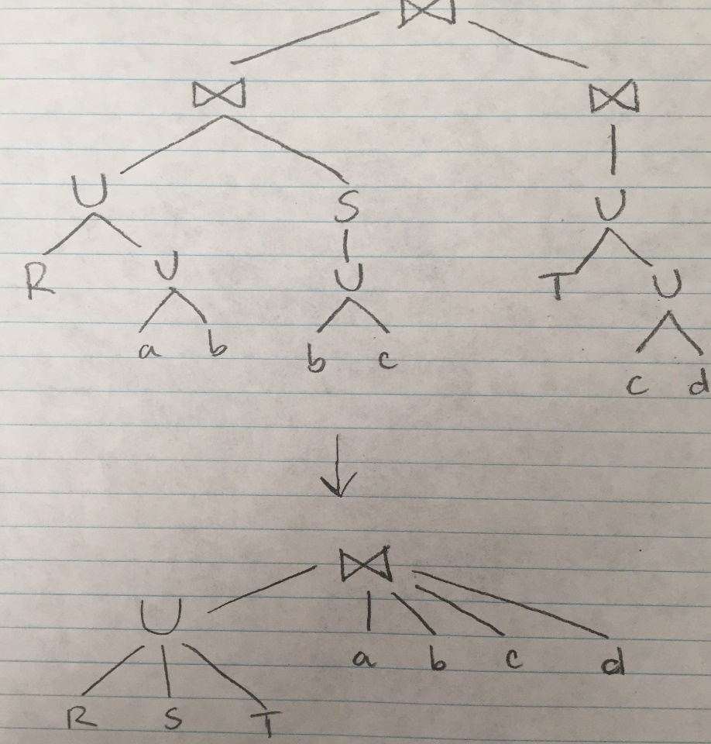

Commutative and associative because all operands are joined so the elements could be reordered.

16.3.1.b

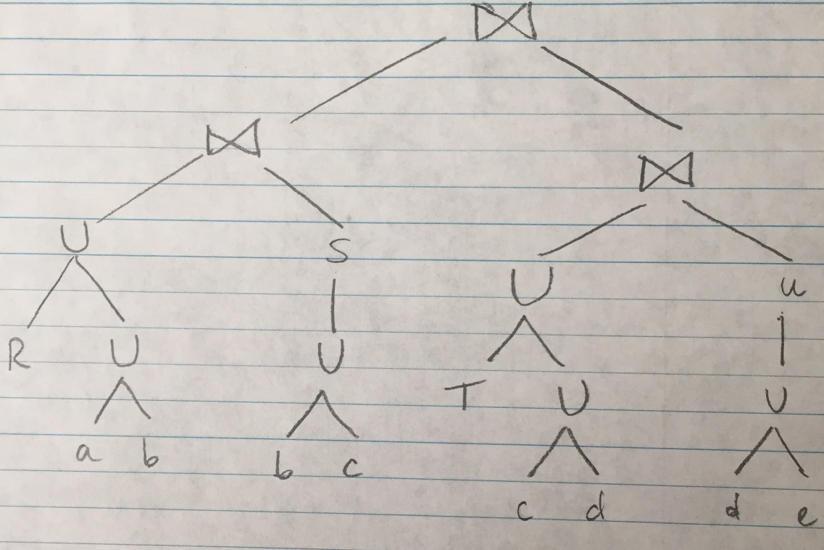

Also commutative and associative for same reasons as 16.3.1.a.

3.3.1.b.i

BCNF Violations: B->C, B->D

3.3.1.b.ii

{(A,B),(B,C,D)}

3.5.1.i

3NF Violations: B->C, B->D

3.5.1.ii

{(A,B),(B,C),(B,D)} or {(A,B),(B,C,D)}